Chapter
Layout Strategies

Discussion Questions
1. The seven layout strategies are:
- Fixed position or project layout
- Process-oriented layout
- Warehouse layout
- Retail layout
- Product-oriented/repetitive layout
- Office layout
- Work cells
2. Fixed position layouts are complicated by: limited space
at virtually all sites; at different stages of the process, different materials are needed; and the volume of materials needed is
dynamic.
3. The advantages of a process layout are:
- It can simultaneously handle a wide variety of products or services, especially in terms of “batches” or “job lots.”
- It has considerable flexibility with respect to equipment and labor assignments.
The disadvantages of a process layout are:
- The use of general purpose rather than special purpose equipment tends to make the overall process somewhat less efficient.
- Orders take more time and money to move through the system because of the difficult scheduling, setting up the process for a wide variety of orders, and considerable material handling.
- Labor skill requirements tend to be high because of the use of general purpose equipment.
- Work-in-process inventories tend to be high.
4. Most organizations have some procedure for documenting movement of their product. For instance, a hospital has doctor’s orders indicating the tests and procedures that a patient is to undergo. A machine shop has routing documents indicating the operations that an order is to follow as the product moves through the shop. And an auto repair shop knows what repairs, parts, and labor are used on a particular job and as a result where the job was done and the trips made necessary.
In each of the above examples a matrix would be made showing the number of trips. And the distance (or time or cost) of each trip would be determined.
5. The advantages of a product layout are:
- The use of special purpose equipment can make the overall process more efficient.
- Individual workloads can usually be made to be relatively equivalent.
- It usually results in low variable cost per unit.
- It tends to keep material handling costs relatively low.
- It reduces work-in-process inventories.
- It makes training and supervision easier than with other layout strategies.
The disadvantages are:
- High volume is required because of the large investment needed to set up the process.
- Work stoppage at any point ties up the whole operation.
- There is a lack of flexibility in handling a variety of products or production rates.
6. Preconditions for high-volume, low-variety products are:
1. Volume is adequate for high equipment utilization
2. Product demand is stable enough to justify high investment in specialized equipment
3. The product is standardized or approaching a phase of its life cycle that justifies investment in specialized
equipment
4. Supplies of raw material and components are adequate and of uniform quality to ensure that they will work with the specialized equipment.
7. Three types of work cells are the small work cell within a plant, focused work center, and focused factory.
8. The advantages of work cells are:
- Reduction in work-in-process inventory
- Reduction in required floor space
- Reduced raw material and finished goods inventory
- Reduced direct labor cost
- Heightened sense of employee participation
- Increased utilization of equipment and machinery
- Reduced investment in machinery and equipment
The disadvantages are:
- Similar to a product layout
- High volume is required because of the large investment needed to set up the process
- There is a lack of flexibility in handling a variety of products or production rates
- Requires the use of group technology
- Requires a high level of training and flexibility on the part of employees
- Either considerable staff support or imaginative employees are needed for the initial development of the work cells
9. The requirements for a focused work center or focused factory are identification of a large family of similar products, a stable demand, and adequate volume to justify the capital investment.
10. Two major trends influencing office layout are dynamic needs for space/services, technology and virtual companies.
11. Some of the layout variables you might want to consider as particularly important in an office where computer programs are to be written are:
- Ease of communication
- Provision of privacy and a quiet work environment
- Lighting—especially as it related to glare on computer screens
- Consideration of ergonomic or human factor issues in equipment layout and construction
12. Some drugstore and grocery chains now allow only limited routes through the store. This (a) allows a high traffic volume to be handled more readily, and (b) forces each customer to be exposed to all merchandise. There are now Internet kiosks in shopping malls.
13. Retail store layout variables that a manager can manipulate are:
- Overall arrangement or pattern through the store
- The allocation of space to individual products
14. Each student will sketch the layout of a local supermarket. They should observe the long aisles, power items at aisle caps, and spread of staples at corners of store (fruit/meat/dairy/bakery).
15. “Random stocking” is placing a unit (product) anywhere in a warehouse that is open (available) for use. This is the opposite of “static” storage where every SKU has its own allotted space.
16. Random stocking works best with sophisticated information systems that rapidly identify items by bar codes (or other scannable IDs), and place them randomly in a warehouse. That requires
(1) open location, (2) accurate records, (3) efficient “picking” sequencing, (4) combining orders, and (5) minimizing distance to “pick” high usage items.
17. Cross-docking means that units are never put in storage in an intermediate storage facility (warehouse). Units are accurately labeled prior to shipment with the information needed to identify the final destination so that when they arrive at an intermediate warehouse or distribution point, they are immediately moved to the shipping dock for transmittal to that final destination.
18. A heuristic is a “rule of thumb” method of problem solving. Line balancing heuristics include: longest task time, most following tasks, ranked positional weights, shortest task time, and least number of following tasks.
Ethical Dilemma
Slotting fees refer to payments by manufacturers for retail shelf space—although the term can mean display or other support—such as a tasting station—for a product. They are the result of:
- New product proliferation (a grocer may handle only 30,000 of 100,000 SKUs available, a book seller has a similar problem)
- High rate of new product failure
- Increase in retailer power (the retailer as “channel
captain”)
Some points for class discussion:
- Slotting fees mean that the small new company has trouble getting products on the shelf.
- Slotting fees tend to reinforce the position of the strong/ major companies.
- The retailer is interested in products that will sell and provide margin—a strong inducement for any good product—if profitable, shelf space will be found.
- As a practical matter, slotting fees can take so many forms (discounts, advertising fees, tasting stations, return policies, etc.) that real control is probably impossible.
- Slotting fees are the inevitable result of the free market at work, one more item in the give and take between buyer and seller.
- Slotting fees may make up half of the profit of a grocer.
- Since the fees are revenue for the retailers, the fees allow lower prices.
- U.S. District Judge Gene Carter held in 2001, in Maine, that slotting fees in a news company distribution case were not illegal.
The authors see no problem with the ethics of slotting fees but would encourage firms not to hide the nature of the payments.
Active Model Exercise
Active Model 9.1: Process Layout
1. What is the current total cost?
$570
2. Assembly (A) and Machine Shop (M) have the highest degree of interaction. Would it be better to swap (A) and Painting or (M) and Painting in order to get (A) and (M) shop next to each other?
Swapping Assembly and Painting lowers the cost, while swapping Assembly and Machine shop raises the cost.
3. Use the Swap button one swap at a time. If the swap helps, move to the next pair. If not, click Swap to put the departments back. What is the minimum total cost after all swaps have been tried?
The cost drops to $510.
4. Look at the two data tables and use the yellow shaded column to put processes in rooms. What room assignments lead to the minimum cost? What is this cost?
Putting the processes in rooms 1,4,2,5,6,3 respectively (yellow shaded area) has a minimum total cost of $460. (Other layouts will have the same cost.)
End-of-Chapter Problems
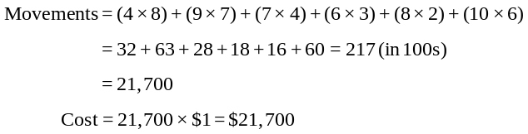9.1
(d) Plan B is the lowest cost, at $20,600.
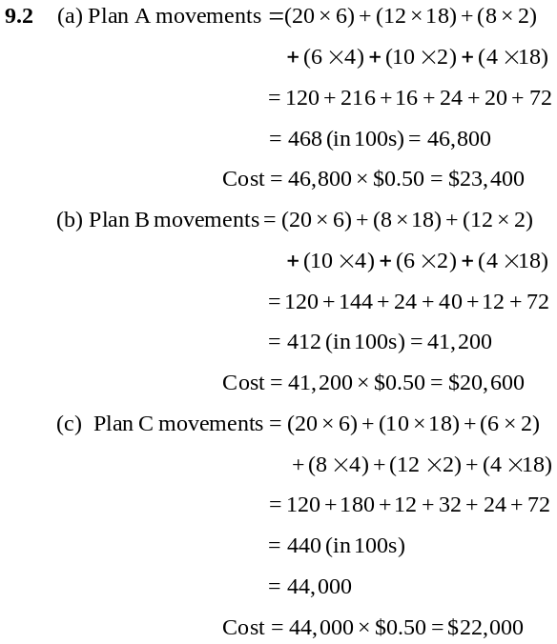9.3 (23 × 10) + (32 × 5) + (20 × 8) = 230 + 160 + 160 = 550
Cost = 550 × $2 = $1,100
9.4 This matrix includes movements in both directions:
 | M | W | D | L | G | B
M | — | 125 | 75 | 0 | 50 | 60
W |  | — | 0 | 75 | 0 | 0
D |  |  | — | 0 | 150 | 20
L |  |  |  | — | 20 | 0
G |  |  |  |  | — | 0
B |  |  |  |  |  | —
Here are two optimal layouts:
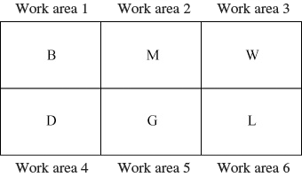

or
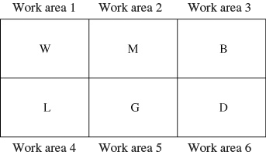

Movement–Distance Calculations
M → W: | 125 × 20 = | 2,500
M → D: | 75 × 40 = | 3,000
M → G: | 50 × 20 = | 1,000
M → B: | 60 × 20 = | 1,200
W → L: | 75 × 20 = | 1,500
D → G: | 150 × 20 = | 3,000
D → B: | 20 × 20 = | 400
L → G: | 20 × 20 = | 400
 |  | 13,000 = Minimum distance movement for both (symmetrical layouts)
9.5
Interstation Activity Matrix
 | Pick Up |  | Pick Up | Verification
 | Paperwork | Advising | Class | of Status
 | and Forms | Station | Cards | and Payment
 | (A) | (B) | (C) | (D)
Paperwork/  Forms (A) | 0 | 450 | 550 | 50
Advising (B) | 350 | 0 | 200 | 0
Class Cards (C) | 0 | 0 | 0 | 750
Verification/  Payment (D) | 0 | 0 | 0 | 0
Interstation Distance Matrix—Original Layout
 | Pick Up |  | Pick Up | Verification
 | Paperwork | Advising | Class | of Status
 | and Forms | Station | Cards | and Payment
 | (A) | (B) | (C) | (D)
Paperwork/  Forms (A) | 0 | 30 | 60 | 90
Advising (B) | 30 | 0 | 30 | 60
Class Cards (C) | 60 | 30 | 0 | 30
Verification/  Payment (D) | 90 | 60 | 30 | 0
Load × Distance
A → B: | 450 × 30 = | 13,500
A → C: | 550 × 60 = | 33,000
A → D: | 50 × 90 = | 4,500
B → A: | 350 × 30 = | 10,500
B → C: | 200 × 30 = | 6,000
C → D: | 750 × 30 = | 22,500
 |  | 90,000
Note: Work areas are “fixed” if using the software to reach this initial answer.
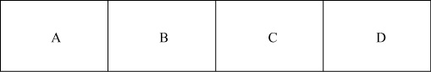
(a) Initial layout:

Interstation Distance Matrix—Improved Layout
 | Pick Up |  | Pick Up | Verification
 | Paperwork | Advising | Class | of Status
 | and Forms | Station | Cards | and Payment
 | (A) | (B) | (C) | (D)
Paperwork/  Forms (A) | 0 | 30 | 30 | 60
Advising (B) | 30 | 0 | 60 | 90
Class Cards (C) | 30 | 60 | 0 | 30
Verification/  Payment (D) | 60 | 90 | 30 | 0
Load × Distance
A → B: | 450 × 30 = | 13,500
A → C: | 550 × 30 = | 16,500
A → D: | 50 × 60 = | 3,000
B → A: | 350 × 30 = | 10,500
B → C: | 200 × 60 = | 12,000
C → D: | 750 × 30 = | 22,500
 |  | 78,000
(b) Improved layout:
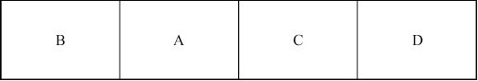
9.6 (a) Layout 1:
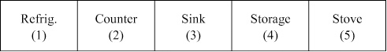

 | Trip Matrix |  |  |  |  |  | Distance Matrix
 | 1 | 2 | 3 | 4 | 5 |  |  | 1 | 2 | 3 | 4 | 5
1 | 0 | 8 | 13 | 0 | 0 |  | 1 | 0 | 4 | 8 | 12 | 16
2 | 5 | 0 | 3 | 3 | 8 |  | 2 | 4 | 0 | 4 | 8 | 12
3 | 3 | 12 | 0 | 4 | 0 |  | 3 | 8 | 4 | 0 | 4 | 8
4 | 3 | 0 | 0 | 0 | 5 |  | 4 | 12 | 8 | 4 | 0 | 4
5 | 0 | 8 | 4 | 10 | 0 |  | 5 | 16 | 12 | 8 | 4 | 0
ΣΣTij × Dij = 600 with work areas fixed (504 if not fixed; 560 if the sink is fixed in one location)
(b) Layout 2:
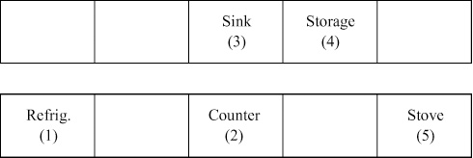

 | Trip Matrix |  |  |  |  |  | Distance Matrix
 | 1 | 2 | 3 | 4 | 5 |  |  | 1 | 2 | 3 | 4 | 5
1 | 0 | 8 | 13 | 0 | 0 |  | 1 | 0 | 7 | 8 | 12 | 14
2 | 5 | 0 | 3 | 3 | 8 |  | 2 | 7 | 0 | 5 | 6 | 7
3 | 3 | 12 | 0 | 4 | 0 |  | 3 | 8 | 5 | 0 | 4 | 9
4 | 3 | 0 | 0 | 0 | 5 |  | 4 | 12 | 6 | 4 | 0 | 6
5 | 0 | 8 | 4 | 10 | 0 |  | 5 | 14 | 7 | 9 | 6 | 0
ΣΣTij × Dij = 602 (if areas are fixed; 566 if not; 595 if the sink is fixed in one location)
9.7 Layout 3:
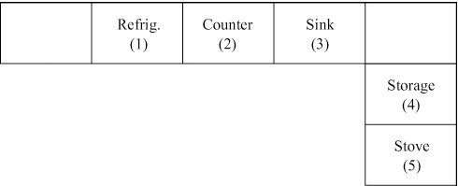
 | Trip Matrix |  |  |  |  |  | Distance Matrix
 | 1 | 2 | 3 | 4 | 5 |  |  | 1 | 2 | 3 | 4 | 5
1 | 0 | 8 | 13 | 0 | 0 |  | 1 | 0 | 4 | 8 | 12 | 14
2 | 5 | 0 | 3 | 3 | 8 |  | 2 | 4 | 0 | 4 | 8 | 10
3 | 3 | 12 | 0 | 4 | 0 |  | 3 | 8 | 4 | 0 | 2 | 8
4 | 3 | 0 | 0 | 0 | 5 |  | 4 | 12 | 8 | 2 | 0 | 4
5 | 0 | 8 | 4 | 10 | 0 |  | 5 | 14 | 10 | 8 | 4 | 0
ΣΣTij × Dij = 560 (if areas are fixed)
9.8 (a) Layout 4:
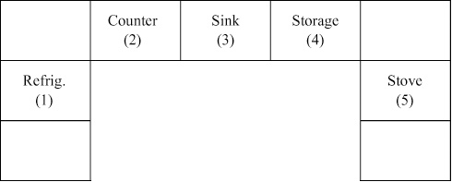

 | Trip Matrix |  |  |  |  |  | Distance Matrix
 | 1 | 2 | 3 | 4 | 5 |  |  | 1 | 2 | 3 | 4 | 5
1 | 0 | 8 | 13 | 0 | 0 |  | 1 | 0 | 5 | 8 | 11 | 13
2 | 5 | 0 | 3 | 3 | 8 |  | 2 | 5 | 0 | 4 | 8 | 11
3 | 3 | 12 | 0 | 4 | 0 |  | 3 | 8 | 4 | 0 | 4 | 8
4 | 3 | 0 | 0 | 0 | 5 |  | 4 | 11 | 8 | 4 | 0 | 5
5 | 0 | 8 | 4 | 10 | 0 |  | 5 | 13 | 11 | 8 | 5 | 0

ΣΣTij × Dij = 609
(b) Layout 5:
ΣΣTij × Dij = 478
 | Trip Matrix |  |  |  |  |  | Distance Matrix
 | 1 | 2 | 3 | 4 | 5 |  |  | 1 | 2 | 3 | 4 | 5
ref-1 | 0 | 8 | 13 | 0 | 0 |  | ref-1 | 0 | 4 | 12 | 12 | 4
coun-2 | 5 | 0 | 3 | 3 | 8 |  | coun-2 | 4 | 0 | 3 | 4 | 4
sink-3 | 3 | 12 | 0 | 4 | 0 |  | sink-3 | 12 | 3 | 0 | 4 | 4
stor-4 | 3 | 0 | 0 | 0 | 5 |  | stor-4 | 12 | 4 | 4 | 0 | 3
stov-5 | 0 | 8 | 4 | 10 | 0 |  | stov-5 | 4 | 4 | 4 | 3 | 0
Solution: Refrig. in Area 3 (where sink was); Counter in Area 4 (where storage was); Sink in Area 2 (where counter was); Storage in Area 1 (where Refrig. was); Stove in Area 5 (no change)
9.9 B and C should be adjacent, because they have the most trips. Traffic is next heaviest between A and D, so they should be adjacent. Continuing in this fashion, F should be adjacent to D and A should be next to F, but the latter two have already been placed. Finally, E should be placed next to F. Thus, we are left with
(a) Heuristic solutions:
B | C | A | D | F | E | = 47,900.
or
A | D | F | E | B | C | = 44,440.
(Note: These are not the optimal solution.)
(b) Better layout:
A | D | F | C | B | E | = 43,880.
9.10 (a) Takt time = Minutes available per day/Units demanded per day
= 420/250 = 1.68 minutes
(b) Number of cross-trained employees = (1.1 + 1.1 + 1.7 + 3.1 + 1.0)/1.68 = 8.0/1.68 = 4.76 ≈ 5
(c) The cleaning operation is substantially longer than the others so it warrants special consideration to ensure that a smooth flow can be maintained. A machine constrained task or lack of cross-training may suggest that more
traditional assembly line balancing techniques be used.
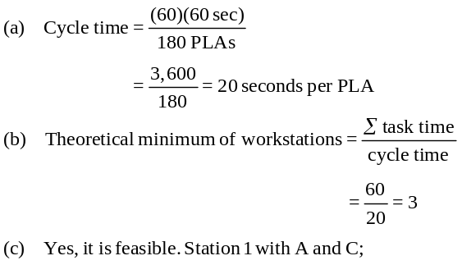9.11

9.12 |  |  | Performance Time |  |  | Task Must Follow
 |  | Task | (in minutes) |  |  | This Task
A |  |  | 4 |  |  | —
B |  |  | 7 |  |  | —
C |  |  | 6 |  |  | A, B
D |  |  | 5 |  |  | C
E |  |  | 6 |  |  | D
F |  |  | 7 |  |  | E
G |  |  | 8 |  |  | E
H |  |  | 6 |  |  | F, G
 |  |  |  | 49
(a, d)

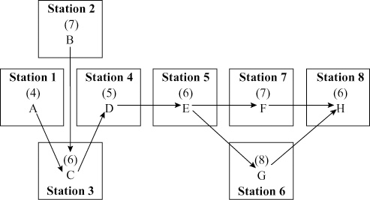

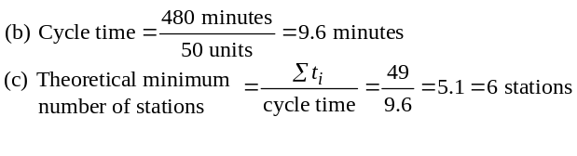

Note that the theoretical minimum could not be achieved.
(e) Total idle time/cycle = 4 + 1 + 2 + 3 + 2 + 1 + 2 = 15 min.
per cycle × 60 cycles = 15 idle hours per day.
(f) Total idle time/day. Since there are 480 minutes, and each chair takes 8 minutes (which is the longest
operation time), there are 480/8 = 60 cycles/day.
Total idle time = 15 minutes/cycle × 60 cycles
= 15 hours
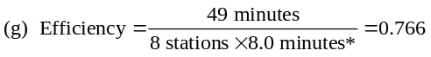or
Efficiency = 76.6%
*Longest operation time
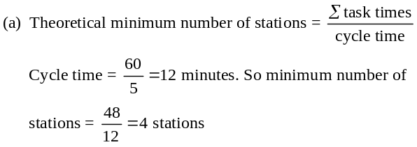9.13
(b)
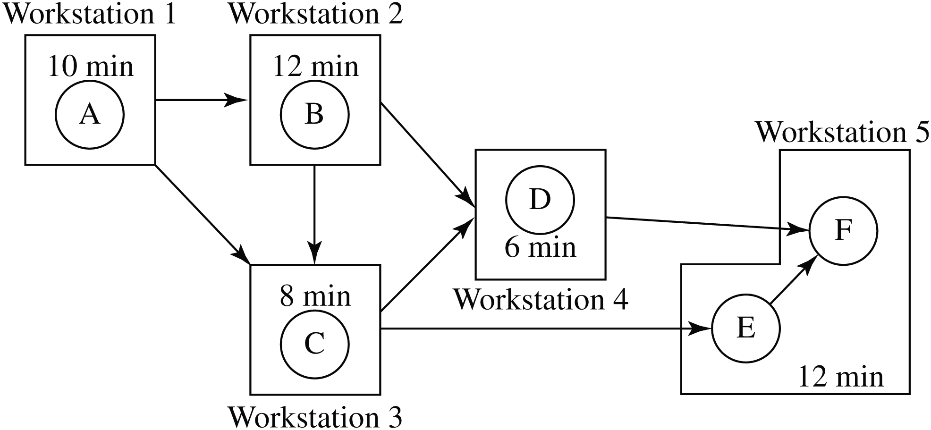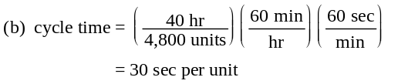

This requires 5 stations—it cannot be done with 4. There is an alternative solution with D and E in workstation #4 and F alone in workstation #5.
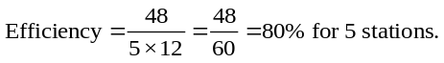(c)

9.14 (a)
 | Performance Time
Task | (in seconds) | Predecessors
A | 20 | None
B | 30 | A
C | 15 | A
D | 15 | A
E | 10 | B,C
F | 30 | D,E

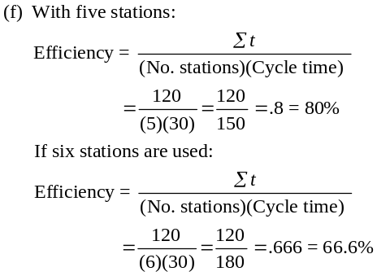

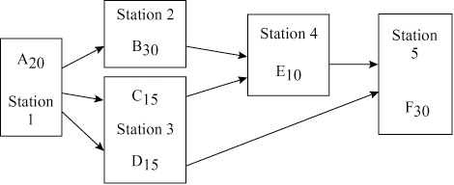

(c) Σt/CT = 120/30 = 4 stations is theoretical minimum.
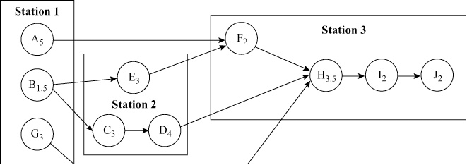
(d) The assembly line balance for a cycle time of 30 seconds requires five stations, as shown below and in part (a) above.
 |  | Time | Time Left | Ready
Station | Task | (sec) | (sec) | Tasks
 |  |  |  | A
1 | A | 20 | 10 | B, C, D
2 | B | 30 |  | C, D
3 | C | 15 | 15 | D, E
 | D | 15 |  | E
4 | E | 10 | 20 | F
5 | F | 30 |  | None
(e) Total idle time = 30 seconds (=10 + 20)

Note: Stations 2 and 5 remain 30 seconds.

9.15 (a)

(b) Station 1 gets A, G, and B and has 0.5 minutes left
over. Station 2 gets C, D, and E, with no time left over. Station 3 gets F, H, I, and J and has 0.5 minutes left over. Improvements in efficiency would seem impossible. The times are in 0.5 minute increments and can’t be sub-divided to achieve exact balance. Total of 1 minute of idle time/cycle.
(c) If stations 1 and 3 each had 0.5 minute more work to do, the line would be 100% efficient; perhaps support tasks could be assigned to them.
 |  | Time | Time Left | Ready
Station | Task | (minutes) | (minutes) | Tasks
1 | A | 5 | 5 | B, G
 | G | 3 | 2 | B
 | B | 1.5 | 0.5 | C, E
2 | C | 3 | 7 | E, D
 | D | 4 | 3 | E
 | E | 3 | 0 | F
3 | F | 2 | 8 | H
 | H | 3.5 | 4.5 | I
 | I | 2 | 2.5 | J
 | J | 2 | 0.5

Summary Statistics
Cycle time | 10 minutes
Time allocated (cyc × sta) | 30 minutes/cycle
Time needed (sum task) | 29 minutes/unit
Idle time (allocated-needed) | 1 minute/cycle
Efficiency (needed/allocated) | 96.67%
Balance delay (1-efficiency) | 3.333%
(d) Theoretical minimum no. of stations = 3

9.16 |  | Performance Time |  |  | Task Must Follow
 | Task | (in minutes) |  |  | This Task
 | A | 1 |  |  | —
 | B | 3 |  |  | A
 | C | 2 |  |  | B
 | D | 4 |  |  | B
 | E | 1 |  |  | C, D
 | F | 3 |  |  | A
 | G | 2 |  |  | F
 | H | 5 |  |  | G
 | I | 1 |  |  | E, H
 | J | 3 |  |  | I
 |  |  | 25
(a, b)
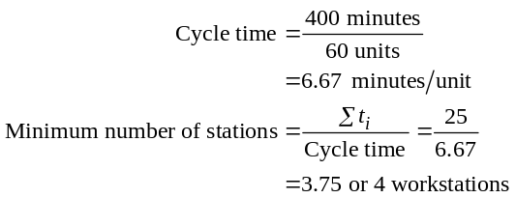Note: Four stations with a 7-minute cycle time is possible; Efficiency would become:
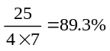
but production drops to 57 from the required 60 units. One five-station solution (there are multiple answers) is:
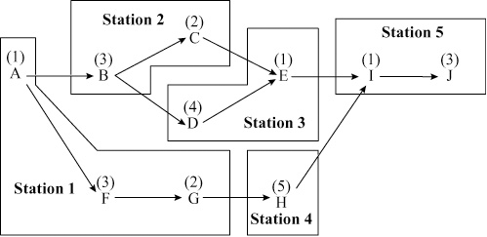
(c) Theoretical:
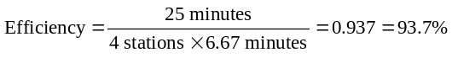
Actual:
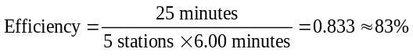
(d) Idle time = 1 + 1 + 1 + 2 = 5 min per cycle
9.17 |  | Performance Time |  |  | Task Must Follow
 | Task | (in minutes) |  |  | This Task
 | A | 1 |  |  | —
 | B | 1 |  |  | A
 | C | 2 |  |  | A
 | D | 1 |  |  | C
 | E | 3 |  |  | C
 | F | 1 |  |  | C
 | G | 1 |  |  | D, E, F
 | H | 2 |  |  | B
 | I | 1 |  |  | G, H
 |  |  | 13
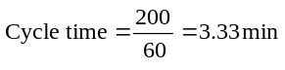
(a)
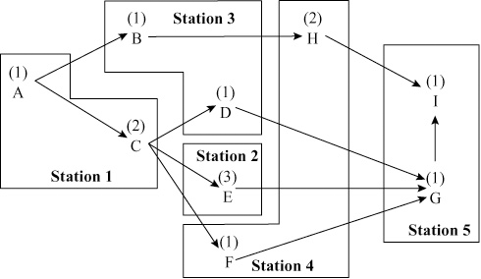

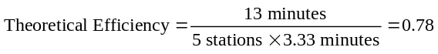(b)
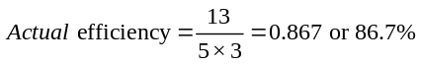or Efficiency = 78% with a cycle time of 3.33. Multiple layouts with this efficiency exist.
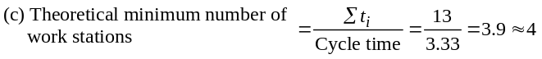
(d) Idle time = 1 (at station 3) + 1 (at station 5) = 2 min per boat
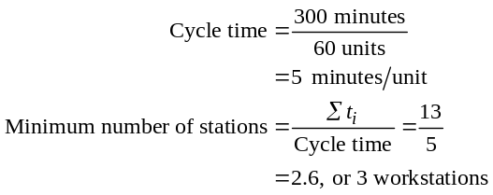9.18 (a) Resolving Problem 9.17 with a production time of 300 minutes per day:

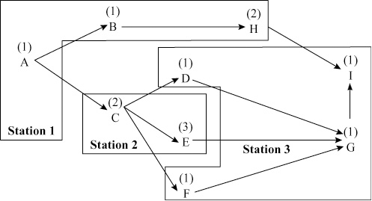

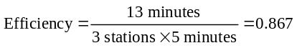 (b)

or Efficiency = 86.7%. Multiple layouts with this efficiency exist.

(c) Resolving Problem 9.17 with a production time of 400 minutes per day:
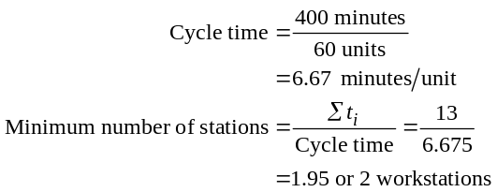

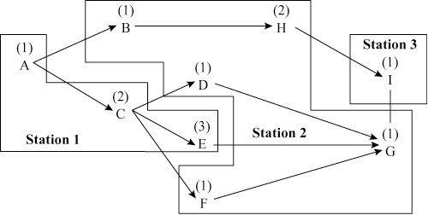

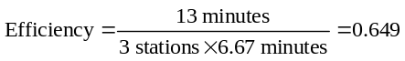
or Efficiency = 64.9%. Multiple layouts with this efficiency exist.
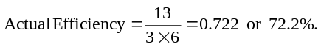
9.19 The assembly-line activities are:
 | Time |  |  |  | Ready |  | Time | Station
Task | (in minutes) |  |  | Predecessors | Tasks |  | Left | Assignment
A | 3 |  |  | None |  | A, B | 1 | 1
B | 6 |  |  | None |  | C, D, E |  | 1
C | 7 |  |  | A |  | D, E, F | 3 | 2
D | 5 |  |  | A, B |  |  |  | 3
E | 2 |  |  | B |  | F, G, H, I | 3 | 3
F | 4 |  |  | C |  |  |  | 4
G | 5 |  |  | F |  | J, H, I, K | 2 | 4
H | 7 |  |  | D, E |  |  |  | 5
I | 1 |  |  | H |  | K, J | 2 | 5
J | 6 |  |  | E |  |  |  | 6
K | 4 |  |  | G, I, J |  |  | 0 | 6
 |  | 50
(a, g)
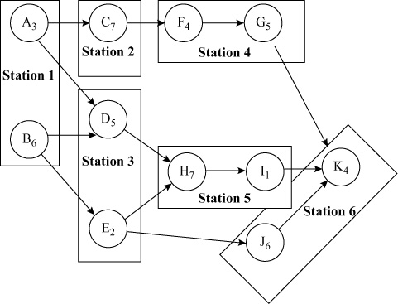

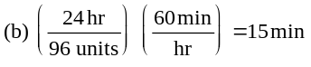

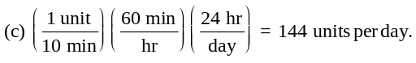

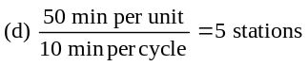

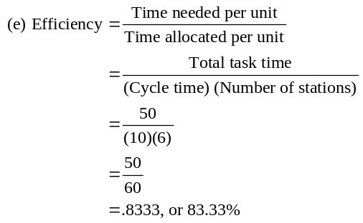

(f) Idle time = Τime allocated per unit − Τime needed per unit
= 60 − 50
= 10 min/cycle
(g) Best assignment is shown in part (a) with the efficiency shown in part (e) (i.e., 83.33%)
9.20
 |  | Performance Time |  |  | Task Must Follow
 | Task | (in minutes) |  |  | This Task
 | A | 5 |  |  | —
 | B | 3 |  |  | A
 | C | 4 |  |  | B
 | D | 3 |  |  | B
 | E | 6 |  |  | C
 | F | 1 |  |  | C
 | G | 4 |  |  | D, E, F
 | H | 2 |  |  | G
 |  |  | 28
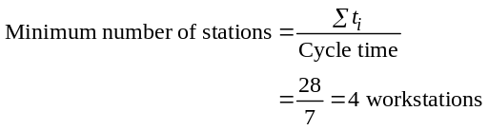

The work activities may be grouped, however, into no fewer than five workstations without violating precedence requirements.
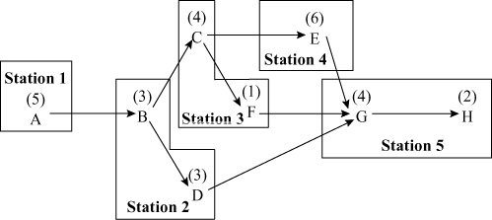

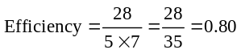

or
Efficiency = 80%
Note that the efficiency of this particular grouping
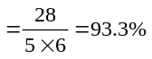

Several other balances are also possible. One of them is to place A alone, tasks B and C together, D and F together, E by itself, and G and H together.
9.21 Note: This problem does not have a computer logo next to it, but it is possible for students to manipulate the input so that POM for Windows or Excel OM can solve the problem.
(a) One possible layout is:
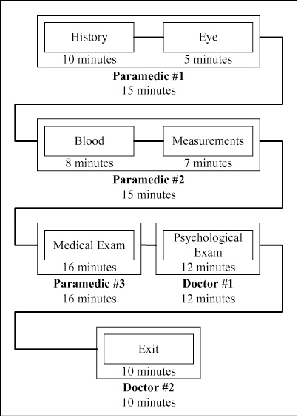

(b) The throughput is 3.75 patients per hour.
(c) The bottleneck is at the medical exam station—16 minutes.
(d) Paramedics are idle 2 minutes, and doctors are idle 10 minutes for each patient.
(e) If one more doctor and one more paramedic are added, it is possible to increase the throughput to at least five per hour with this simple layout:

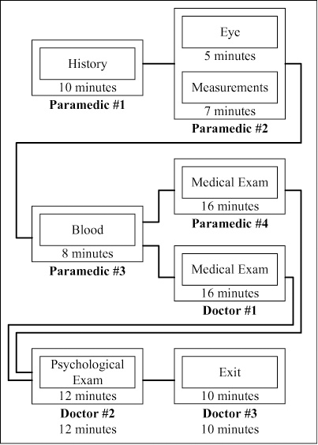

The bottlenecks are now the two stations, psychological exam and eye/measurements, taking 12 minutes.
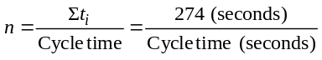9.22 (a)
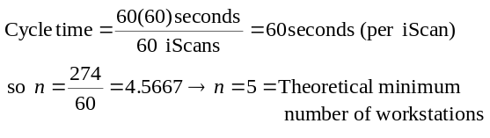

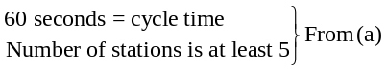(b)

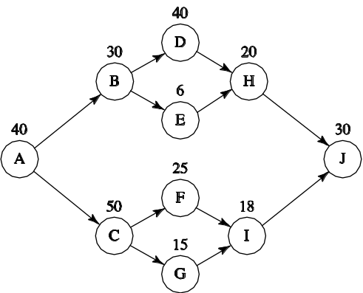
Precedence diagram:

Task | Number of Successors |  | Task | Number of Successors
A | 9 |  | F | 2
B | 4 |  | G | 2
C | 4 |  | H | 1
D | 2 |  | I | 1
E | 2 |  | J | 0

 | Available |  | Available and Fit | Assigned
Station 1 | A |  | A | A
 | B, C |  | — | —
Station 2 | B, C |  | B, C | C | (Broke a tie)
 | B, F, G |  | — | —
Station 3 | B, F, G |  | B, F, G | B
 | D, E, F G |  | E, F, G | F | (Broke ties)
 | D, E, G |  | — | —
Station 4 | D, E, G |  | D, E, G | D | (Broke ties)
 | E, G |  | E, G | G | (Broke a tie)
 | E, I |  | — | —
Station 5 | E, I |  | E, I | E
 | I, H |  | I, H | H | (Broke a tie)
 | I |  | I | I
 | J |  | — | —
Station 6 | J |  | J | J
Answer: |  | Station |  | Tasks
(Other answers possible, depending upon how ties are broken in above procedure) |  | 1  2  3  4  5  6 |  | A  C  B, F  D, G  E, H, I  J
(c) n = 6 workstations in our answer.
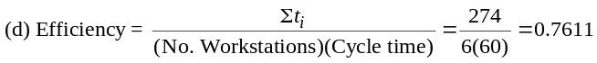

9.23 (a) Using a 40-hour week:
Cottrell Bicycle Co.
Fewest Following Tasks |  |  |  | Cycle Time = 144 Seconds
Station | Task | Time | Time Left |  | Ready Tasks
1 | J3 | 3 | 141 |  | K3, F7
 | F7 | 21 | 120 |  | K3, C1
 | C1 | 78 | 42 |  | K3, B5
2 | B5 | 108 | 36 |  | K3, A1, A2
3 | A2 | 72 | 72 |  | K3, A1
 | A1 | 52 | 20 |  | K3
4 | K3 | 60 | 84 |  | K4, K9, J1, J2
 | K4 | 24 | 60 |  | K9, J1, J2
 | K9 | 27 | 33 |  | J1, J2, G4
 | J2 | 22 | 11 |  | J1, G4, F3, F4
5 | G4 | 79 | 65 |  | J1, F3, F4, F9
 | F3 | 32 | 33 |  | J1, F4, F9, E3
6 | F9 | 126 | 18 |  | J1, F4, E3
7 | E3 | 109 | 35 |  | J1, F4
8 | J1 | 66 | 78 |  | F4, G5
 | G5 | 29 | 49 |  | F4, E2
 | E2 | 18 | 31 |  | F4, D7
9 | D7 | 72 | 72 |  | F4
10 | F4 | 92 | 52 |  | D6
11 | D6 | 53 | 91 |  | D8, D9
 | D8 | 78 | 13 |  | D9
12 | D9 | 37 | 107 |  | B3
 | B3 | 72 | 35 |  | B7
 | B7 | 18 | 17 |  | A3
13 | A3 | 114 | 30
Time allocated (cyc × sta) = 1872; Min (theoretical) # of stations = 11
Time needed (sum task) = 1462; Efficiency = 78.10%;
Idle time (allocated-needed) = 410 seconds per cycle

Cottrell Bicycle Co.
Longest Operation Time |  |  |  | Cycle Time = 144 Seconds
Station | Task | Time |  | Time Left |  | Ready Tasks
1 | K3 | 60 |  | 84 | J3, K4, K9, J1, J2
 | J1 | 66 |  | 18 | J3, K4, K9, J2
 | J3 | 3 |  | 15 | K4, K9, J2, F7
2 | K9 | 27 |  | 117 | K4, J2, F7, G5
 | G5 | 29 |  | 88 | K4, J2, F7
 | K4 | 24 |  | 64 | J2, F7, G4
 | J2 | 22 |  | 42 | F7, G4, F3, F4
 | F3 | 32 |  | 10 | F7, G4, F4, E2, E3
3 | E3 | 109 |  | 35 | F7, G4, F4, E2
 | F7 | 21 |  | 14 | G4, F4, E2, C1
4 | F4 | 92 |  | 52 | G4, E2, C1, D6
 | E2 | 18 |  | 34 | G4, C1, D6
5 | G4 | 79 |  | 65 | C1, D6, F9
 | D6 | 53 |  | 12 | C1, F9, D8, D9
6 | F9 | 126 |  | 18 | C1, D8, D9, D7
7 | C1 | 78 |  | 66 | D8, D9, D7, B5
 | D9 | 37 |  | 29 | D8, D7, B5
8 | B5 | 108 |  | 36 | D8, D7, A1, A2
9 | D8 | 78 |  | 66 | D7, A1, A2
 | A1 | 52 |  | 14 | D7, A2
10 | D7 | 72 |  | 72 | A2, B3
 | A2 | 72 |  | 0 | B3
11 | B3 | 72 |  | 72 | B7
 | B7 | 18 |  | 54 | A3
12 | A3 | 114 |  | 30
Time allocated (cyc × sta) = 1728; Min (theoretical) # of stations = 11
Time needed (sum task) = 1462; Efficiency = 84.61%;
Idle time (alloc-needed) = 266 seconds per cycle
Cottrell Bicycle Co.
Most Following Tasks |  |  |  | Cycle Time = 144 Seconds
Station | Task | Time |  | Time Left |  | Ready Tasks
1 | K3 | 60 |  | 84 | J3, K4, K9, J1, J2
 | J2 | 22 |  | 62 | J3, K4, K9, J1, F3, F4
 | J3 | 3 |  | 59 | K4, K9, J1, F3, F4, F7
 | K9 | 27 |  | 32 | K4, J1, F3, F4, F7
 | F3 | 32 |  | 0 | K4, J1, F4, F7, E3
2 | F7 | 21 |  | 123 | K4, J1, F4, E3, C1
 | K4 | 24 |  | 99 | J1, F4, E3, C1, G4
 | J1 | 66 |  | 33 | F4, E3, C1, G4, G5
 | G5 | 29 |  | 4 | F4, E3, C1, G4, E2
3 | F4 | 92 |  | 52 | E3, C1, G4, E2, D6
 | E2 | 18 |  | 34 | E3, C1, G4, D6
4 | C1 | 78 |  | 66 | E3, G4, D6, B5
 | D6 | 53 |  | 13 | E3, G4, B5, D9
5 | E3 | 109 |  | 35 | G4, B5, D9, D8
6 | G4 | 79 |  | 65 | B5, D9, D8, F9
 | D9 | 37 |  | 28 | B5, D8, F9
7 | F9 | 126 |  | 18 | B5, D8, D7
8 | B5 | 108 |  | 36 | D8, D7, A1, A2
9 | D8 | 78 |  | 66 | D7, A1, A2
 | A1 | 52 |  | 14 | D7, A2
10 | D7 | 72 |  | 72 | A2, B3
 | B3 | 72 |  | 0 | A2, B7
11 | B7 | 18 |  | 126 | A2, A3
 | A2 | 72 |  | 54 | A3
12 | A3 | 114 |  | 30
Time allocated (cyc × sta) = 1728; Min (theoretical) # of stations = 11
Time needed (sum task) = 1462; Efficiency = 84.61%;
Idle time (alloc-needed) = 266 seconds per cycle

Cottrell Bicycle Co.
Ranked Positional Weight |  |  |  | Cycle Time = 144 Seconds
Station | Task | Time |  | Time Left |  | Ready Tasks
1 | K3 | 60 |  | 84 | J3, K4, K9, J1, J2
 | J2 | 22 |  | 62 | J3, K4, K9, J1, F3, F4
 | K9 | 27 |  | 35 | J3, K4, J1, F3, F4
 | J3 | 3 |  | 32 | K4, J1, F3, F4, F7
 | F7 | 21 |  | 11 | K4, J1, F3, F4, C1
2 | C1 | 78 |  | 66 | K4, J1, F3, F4, B5
 | F3 | 32 |  | 34 | K4, J1, F4, B5, E3
 | K4 | 24 |  | 10 | J1, F4, B5, E3, G4
3 | G4 | 79 |  | 65 | J1, F4, B5, E3, F9
4 | F4 | 92 |  | 52 | J1, B5, E3, F9, D6
5 | E3 | 109 |  | 35 | J1, B5, F9, D6
6 | F9 | 126 |  | 18 | J1, B5, D6
7 | J1 | 66 |  | 78 | B5, D6, G5
 | D6 | 53 |  | 25 | B5, G5, D8, D9
8 | B5 | 108 |  | 36 | G5, D8, D9, A1, A2
 | G5 | 29 |  | 7 | D8, D9, A1, A2, E2
9 | E2 | 18 |  | 126 | D8, D9, A1, A2, D7
 | D8 | 78 |  | 48 | D9, A1, A2, D7
 | D9 | 37 |  | 11 | A1, A2, D7
10 | D7 | 72 |  | 72 | A1, A2, B3
 | B3 | 72 |  | 0 | A1, A2, B7
11 | A1 | 52 |  | 92 | A2, B7
 | B7 | 18 |  | 74 | A2, A3
 | A2 | 72 |  | 2 | A3
12 | A3 | 114 |  | 30
Time allocated (cyc × sta) = 1728; Min (theoretical) # of stations = 11
Time needed (sum task) = 1462; Efficiency = 84.61%;
Idle time (alloc-needed) = 266 seconds per cycle

Cottrell Bicycle Co.
Shortest Operation Time |  |  |  | Cycle Time = 144 Seconds
Station | Task | Time |  | Time Left |  | Ready Tasks
1 | J3 | 3 |  | 141 | K3, F7
 | F7 | 21 |  | 120 | K3, C1
 | K3 | 60 |  | 60 | C1, K4, K9, J1, J2
 | J2 | 22 |  | 38 | C1, K4, K9, J1, F3, F4
 | K4 | 24 |  | 14 | C1, K9, J1, F3, F4
2 | K9 | 27 |  | 117 | C1, J1, F3, F4, G4
 | F3 | 32 |  | 85 | C1, J1, F4, G4, E3
 | J1 | 66 |  | 19 | C1, F4, G4, E3, G5
3 | G5 | 29 |  | 115 | C1, F4, G4, E3, E2
 | E2 | 18 |  | 97 | C1, F4, G4, E3
 | C1 | 78 |  | 19 | F4, G4, E3, B5
4 | G4 | 79 |  | 65 | F4, E3, B5, F9
5 | F4 | 92 |  | 52 | E3, B5, F9, D6
6 | D6 | 53 |  | 91 | E3, B5, F9, D9
 | D9 | 37 |  | 54 | E3, B5, F9
7 | B5 | 108 |  | 36 | E3, F9, A1, A2
8 | A1 | 52 |  | 92 | E3, F9, A2
 | A2 | 72 |  | 20 | E3, F9
9 | E3 | 109 |  | 35 | F9, D8
10 | D8 | 78 |  | 66 | F9
11 | F9 | 126 |  | 18 | D7
12 | D7 | 72 |  | 72 | B3
 | B3 | 72 |  | 0 | B7
13 | B7 | 18 |  | 126 | A3
 | A3 | 114 |  | 12
Time allocated (cyc × sta) = 1872; Min (theoretical) # of stations = 11
Time needed (sum task) = 1462; Efficiency = 78.10%;
Idle time (alloc-needed) = 410 seconds per cycle
Summary:
 | Number of
Algorithm | Workstations | Efficiency
Fewest following tasks | 13 | 78.1
Longest operation time | 12 | 84.6
Most following tasks | 12 | 84.6
Ranked positional weight | 12 | 84.6
Shortest operation time | 13 | 78.1
The longest operation time, most following tasks, and ranked positional weight algorithms gave equal efficiencies of 84.61%.

(b) Using a 41-hour week:
Cottrell Bicycle Co.
Fewest Following Tasks |  |  |  | Cycle Time = 147.6 Seconds
Station | Task | Time |  | Time Left | Ready Tasks
1 | J3 | 3 |  | 144.60 | K3, F7
 | F7 | 21 |  | 123.60 | K3, C1
 | C1 | 78 |  | 45.60 | K3, B5
2 | B5 | 108 |  | 39.60 | K3, A1, A2
3 | A2 | 72 |  | 75.60 | K3, A1
 | A1 | 52 |  | 23.60 | K3
4 | K3 | 60 |  | 87.60 | K4, K9, J1, J2
 | K4 | 24 |  | 63.60 | K9, J1, J2
 | K9 | 27 |  | 36.60 | J1, J2, G4
 | J2 | 22 |  | 14.60 | J1, G4, F3, F4
5 | G4 | 79 |  | 68.60 | J1, F3, F4, F9
 | J1 | 66 |  | 2.60 | F3, F4, F9, G5
6 | F9 | 126 |  | 21.60 | F3, F4, G5
7 | G5 | 29 |  | 118.60 | F3, F4
 | F4 | 92 |  | 26.60 | F3, D6
8 | D6 | 53 |  | 94.60 | F3, D9
 | D9 | 37 |  | 57.60 | F3
 | F3 | 32 |  | 25.60 | E2, E3
 | E2 | 18 |  | 7.60 | E3
9 | E3 | 109 |  | 38.60 | D7, D8
10 | D7 | 72 |  | 75.60 | D8
11 | D8 | 78 |  | 69.60 | B3
12 | B3 | 72 |  | 75.60 | B7
 | B7 | 18 |  | 57.60 | A3
13 | A3 | 114 |  | 33.60
Time allocated (cyc × sta) = 1918.80; Min (theoretical) # of stations = 10
Time needed (sum task) = 1462.00; Efficiency = 76.19%;
Idle time (alloc-needed) = 456.80 seconds per cycle

Cottrell Bicycle Co.
Longest Operation Time |  |  |  | Cycle Time = 147.6 Seconds
Station | Task | Time |  | Time Left |  | Ready Tasks
1 | K3 | 60 |  | 87.60 | J3, K4, K9, J1, J2
 | J1 | 66 |  | 21.60 | J3, K4, K9, J2
 | J3 | 3 |  | 18.60 | K4, K9, J2, F7
2 | K9 | 27 |  | 120.60 | K4, J2, F7, G5
 | G5 | 29 |  | 91.60 | K4, J2, F7
 | K4 | 24 |  | 67.60 | J2, F7, G4
 | J2 | 22 |  | 45.60 | F7, G4, F3, F4
 | F3 | 32 |  | 13.60 | F7, G4, F4, E2, E3
3 | E3 | 109 |  | 38.60 | F7, G4, F4, E2
 | F7 | 21 |  | 17.60 | G4, F4, E2, C1
4 | F4 | 92 |  | 55.60 | G4, E2, C1, D6
 | D6 | 53 |  | 2.60 | G4, E2, C1, D8, D9
5 | G4 | 79 |  | 68.60 | E2, C1, D8, D9, F9
 | D9 | 37 |  | 31.60 | E2, C1, D8, F9
 | E2 | 18 |  | 13.60 | C1, D8, F9
6 | F9 | 126 |  | 21.60 | C1, D8, D7
7 | C1 | 78 |  | 69.60 | D8, D7, B5
8 | B5 | 108 |  | 39.60 | D8, D7, A1, A2
9 | D8 | 78 |  | 69.60 | D7, A1, A2
 | A1 | 52 |  | 17.60 | D7, A2
10 | D7 | 72 |  | 75.60 | A2, B3
 | A2 | 72 |  | 3.60 | B3
11 | B3 | 72 |  | 75.60 | B7
 | B7 | 18 |  | 57.60 | A3
12 | A3 | 114 |  | 33.60
Time allocated (cyc × sta) = 1771.20; Min (theoretical) # of stations = 10
Time needed (sum task) = 1462.00; Efficiency = 82.54%;
Idle time (alloc-needed) = 309.20 seconds per cycle

Cottrell Bicycle Co.
Most Following Tasks |  |  |  |  | Cycle Time = 147.6 Seconds
Station | Task | Time |  | Time Left |  | Ready Tasks
1 | K3 | 60 |  | 87.60 |  | J3, K4, K9, J1, J2
 | J2 | 22 |  | 65.60 |  | J3, K4, K9, J1, F3, F4
 | J3 | 3 |  | 62.60 |  | K4, K9, J1, F3, F4, F7
 | K9 | 27 |  | 35.60 |  | K4, J1, F3, F4, F7
 | F3 | 32 |  | 3.60 |  | K4, J1, F4, F7, E3
2 | F7 | 21 |  | 126.60 |  | K4, J1, F4, E3, C1
 | K4 | 24 |  | 102.60 |  | J1, F4, E3, C1, G4
 | J1 | 66 |  | 36.60 |  | F4, E3, C1, G4, G5
 | G5 | 29 |  | 7.60 |  | F4, E3, C1, G4, E2
3 | F4 | 92 |  | 55.60 |  | E3, C1, G4, E2, D6
 | D6 | 53 |  | 2.60 |  | E3, C1, G4, E2, D9
4 | C1 | 78 |  | 69.60 |  | E3, G4, E2, D9, B5
 | E2 | 18 |  | 51.60 |  | E3, G4, D9, B5
 | D9 | 37 |  | 14.60 |  | E3, G4, B5
5 | E3 | 109 |  | 38.60 |  | G4, B5, D8
6 | G4 | 79 |  | 68.60 |  | B5, D8, F9
7 | F9 | 126 |  | 21.60 |  | B5, D8, D7
8 | B5 | 108 |  | 39.60 |  | D8, D7, A1, A2
9 | D8 | 78 |  | 69.60 |  | D7, A1, A2
 | A1 | 52 |  | 17.60 |  | D7, A2
10 | D7 | 72 |  | 75.60 |  | A2, B3
 | B3 | 72 |  | 3.60 |  | A2, B7
11 | B7 | 18 |  | 129.60 |  | A2, A3
 | A2 | 72 |  | 57.60 |  | A3
12 | A3 | 114 |  | 33.60
Time allocated (cyc × sta) = 1771.20; Min (theoretical) # of stations = 10
Time needed (sum task) = 1462.00; Efficiency = 82.54%;
Idle time (alloc-needed) = 309.20 seconds per cycle

Cottrell Bicycle Co.
Ranked Positional Weight |  |  |  |  | Cycle Time = 147.6 Seconds
Station | Task | Time |  | Time Left |  | Ready Tasks
1 | K3 | 60 |  | 87.60 |  | J3, K4, K9, J1, J2
 | J2 | 22 |  | 65.60 |  | J3, K4, K9, J1, F3, F4
 | K9 | 27 |  | 38.60 |  | J3, K4, J1, F3, F4
 | J3 | 3 |  | 35.60 |  | K4, J1, F3, F4, F7
 | F7 | 21 |  | 14.60 |  | K4, J1, F3, F4, C1
2 | C1 | 78 |  | 69.60 |  | K4, J1, F3, F4, B5
 | F3 | 32 |  | 37.60 |  | K4, J1, F4, B5, E3
 | K4 | 24 |  | 13.60 |  | J1, F4, B5, E3, G4
3 | G4 | 79 |  | 68.60 |  | J1, F4, B5, E3, F9
 | J1 | 66 |  | 2.60 |  | F4, B5, E3, F9, G5
4 | F4 | 92 |  | 55.60 |  | B5, E3, F9, G5, D6
 | D6 | 53 |  | 2.60 |  | B5, E3, F9, G5, D9
5 | E3 | 109 |  | 38.60 |  | B5, F9, G5, D9, D8
 | G5 | 29 |  | 9.60 |  | B5, F9, D9, D8, E2
6 | F9 | 126 |  | 21.60 |  | B5, D9, D8, E2
 | E2 | 18 |  | 3.60 |  | B5, D9, D8, D7
7 | B5 | 108 |  | 39.60 |  | D9, D8, D7, A1, A2
 | D9 | 37 |  | 2.60 |  | D8, D7, A1, A2
8 | D8 | 78 |  | 69.60 |  | D7, A1, A2
 | A1 | 52 |  | 17.60 |  | D7, A2
9 | D7 | 72 |  | 75.60 |  | A2, B3
 | B3 | 72 |  | 3.60 |  | A2, B7
10 | B7 | 18 |  | 129.60 |  | A2, A3
 | A3 | 114 |  | 15.60 |  | A2
11 | A2 | 72 |  | 75.60
Time allocated (cyc × sta) = 1623.60; Min (theoretical) # of stations = 10
Time needed (sum task) = 1462.00; Efficiency = 90.05%;
Idle time (alloc-needed) = 161.60 seconds per cycle

Cottrell Bicycle Co.
Shortest Operation Time |  |  |  |  | Cycle Time = 147.6 Seconds
Station | Task | Time |  | Time Left |  | Ready Tasks
1 | J3 | 3 |  | 144.60 |  | K3, F7
 | F7 | 21 |  | 123.60 |  | K3, C1
 | K3 | 60 |  | 63.60 |  | C1, K4, K9, J1, J2
 | J2 | 22 |  | 41.60 |  | C1, K4, K9, J1, F3, F4
 | K4 | 24 |  | 17.60 |  | C1, K9, J1, F3, F4
2 | K9 | 27 |  | 120.60 |  | C1, J1, F3, F4, G4
 | F3 | 32 |  | 88.60 |  | C1, J1, F4, G4, E3
 | J1 | 66 |  | 22.60 |  | C1, F4, G4, E3, G5
3 | G5 | 29 |  | 118.60 |  | C1, F4, G4, E3, E2
 | E2 | 18 |  | 100.60 |  | C1, F4, G4, E3
 | C1 | 78 |  | 22.60 |  | F4, G4, E3, B5
4 | G4 | 79 |  | 68.60 |  | F4, E3, B5, F9
5 | F4 | 92 |  | 55.60 |  | E3, B5, F9, D6
 | D6 | 53 |  | 2.60 |  | E3, B5, F9, D9
6 | D9 | 37 |  | 110.60 |  | E3, B5, F9
 | B5 | 108 |  | 2.60 |  | E3, F9, A1, A2
7 | A1 | 52 |  | 95.60 |  | E3, F9, A2
 | A2 | 72 |  | 23.60 |  | E3, F9
8 | E3 | 109 |  | 38.60 |  | F9, D8
9 | D8 | 78 |  | 69.60 |  | F9
10 | F9 | 126 |  | 21.60 |  | D7
11 | D7 | 72 |  | 75.60 |  | B3
 | B3 | 72 |  | 3.60 |  | B7
12 | B7 | 18 |  | 129.60 |  | A3
 | A3 | 114 |  | 15.60
Time allocated (cyc × sta) = 1771.20; Min (theoretical) # of stations = 10
Time needed (sum task) = 1462.00; Efficiency = 82.54%;
Idle time (alloc-needed) = 309.20 seconds per cycle
Summary:
 | Number of
Algorithm | Workstations | Efficiency
Fewest following tasks | 13 | 76.2
Longest operation time | 12 | 82.5
Most following tasks | 12 | 82.5
Ranked positional weight | 11 | 90.1
Shortest operation time | 12 | 82.5
The ranked positional weight algorithm gave the highest efficiency—90.05%.
Additional Homework Problems
Here are the answers to additional homework problems that are located on our Companion Web site, at www.myomlab.com.
9.24
Current layout:
Entrance 1 | Exam I 2 | Exam II 5 | X-ray 4
Lab, EKG 5 | O.R. 6 | R.R. 7 | Casts 8
Patient movement = 6,700 feet
Improved layout:
Entrance 1 | Exam I 2 | Lab, EKG 5 | O.R. 6
Exam II 3 | X-ray 4 | R.R. 7 | Casts 8
Patient movement = 4,800 feet
Improved layout:
Entrance 1 | Exam I 2 | Lab, EKG 5 | O.R. 6
Exam II 3 | X-ray 4 | Casts 8 | R.R. 7
Patient movement = 4,700 feet
More improved layout (with Exam rooms swapped):
Entrance 1 | Exam II 3 | Lab, EKG 5 | O.R. 6
Exam I 2 | X-ray 4 | Casts 8 | R.R. 7
Patient movement = 4,500 feet
Note that this final solution reflects “common sense,” or the result of one’s intuition. We simply allocate the spaces in the order in which the tasks are usually performed. We usually start at the “entrance,” proceed to an examination room; from the exam-ination room, proceed for either x-rays or lab tests, then (a) leave the facility, (b) go to get a cast put on, or (c) go for surgery.

9.25 |  | Performance Time |  |  | Task Must Follow
 | Task | (in minutes) |  |  | This Task
 | A | 1 |  |  | —
 | B | 1 |  |  | —
 | C | 4 |  |  | A, B
 | D | 1 |  |  | C
 | E | 2 |  |  | D
 | F | 4 |  |  | E
 |  |  | 13

(b) 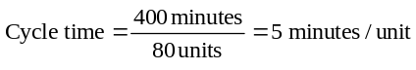
(c) 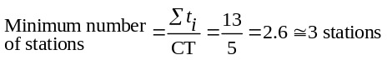
(a) & (d)
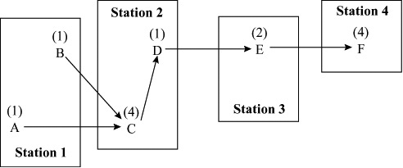
(e) 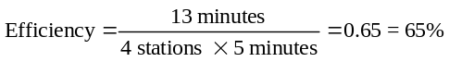
Multiple layouts are possible.
9.26 (a)
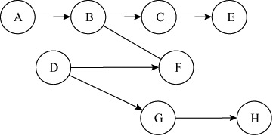

(b) There are multiple alternatives. Here is one that does not violate any procedures.
Station | Tasks
1 | A, D
2 | B, G
3 | C, F
4 | H, E
(c) Each alternative has an overall efficiency of 92.5%.

9.27 |  | Performance Time |  |  | Task Must Follow
 | Task | (in minutes) |  |  | This Task
 | A | 13 |  |  | —
 | B | 4 |  |  | A
 | C | 10 |  |  | B
 | D | 10 |  |  | —
 | E | 6 |  |  | D
 | F | 12 |  |  | E
 | G | 5 |  |  | E
 | H | 6 |  |  | F, G
 | I | 7 |  |  | H
 | J | 5 |  |  | H
 | K | 4 |  |  | I, J
 | L | 15 |  |  | C, K
 |  |  | 97

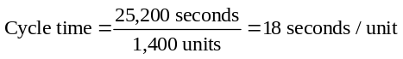
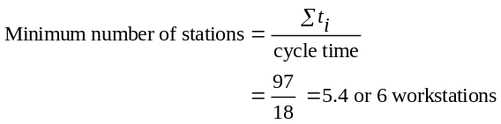
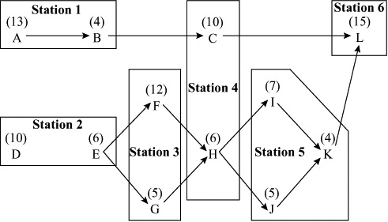
Total idle time = 11 seconds
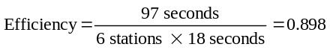
or
Efficiency = 89.8%
Case Study
STATE AUTOMOBILE LICENSE RENEWALS
1. What is the maximum number of applications per hour that can be handled by the present configuration of the process?
The process times and activities for each activity are identical because all have only one station. The maximum output of renewals will be limited to 60 renewals/hour (3600 sec/hr ÷ 60 sec/renewal) by the bottleneck or longest process time.
If each step in the process is handled by one person, it can be seen that each station will be waiting for the clerk who checks the file for violations. This is because this step takes the longest
(60 seconds). The task of “check file” will be the bottleneck, and a line will build up in front of this station. The clerk and expensive equipment for the photographic step will be idle approximately 1/3 of the time (20 seconds ÷ 60 seconds).
A balanced line process is one in which the process times of each station are the same. An obvious way to balance the line is to add stations to the bottleneck activity. However, this may not be the most efficient solution. In some cases, it is possible to combine activities creatively and make more productive use of workers.
2. How many applications can be processed per hour if a second clerk is added to check for violations?
If a second file clerk is added to the activity of checking files,
the process time for this activity is reduced to 30 sec/location
(60 seconds/2 locations). The bottleneck now becomes the eye test. The maximum output of renewals becomes 90 renewals/hour (3600 sec/hour ÷ 40 sec/renewal).
3. Assuming the addition of a second clerk (anywhere you choose), what is the maximum number of applications the process can handle?
Solution C
Job | Time  (sec) | Station | Process  Time (sec) | Maximum  Output  (per hr) |  | Cost/hour
1 + 2 + 3 + 4 | 145 | 5 | 29 | 124.1 |  | $60.00
5 | 20 | 1 | 20 | 180 | 16.00 + 10.00
6 | 30 | 1 | 30 | 120* |  |  |  | 18.00
Cost per renewal = $104.00 ÷120 = $0.867 $104.00
* Indicates a bottleneck step.

If activities 1, 2, and 3 can be successfully combined to form a new activity taking 105 seconds that is accomplished by the same three people, the process time of the new combined task is
35 seconds. So without adding any personnel, as was done above, it is possible to process up to 90 renewals per hour.
Creative rearranging and combining of tasks can produce other cycle times. The only limitations are: (1) the tasks must be performed in a logical sequence, and (2) the facilities and equipment must be available for the tasks.
4. How would you suggest modifying the process in order to accommodate 120 applications per hour?
This question requires trial-and-error creation of proposed solutions. Presented below are proposed solutions that each result in the capacity for handling 120 renewals per hour. Solution A was achieved by simply expanding the number of stations performing each job so that at least 120 licenses are processed per hour. Solution B combines jobs such that the process time at most stations equals the bottleneck process time (or cycle time). Although this reduced the number of employees from 8 to 7, one of these is an additional photographer with another camera. So the total costs is increased. Solutions C and D produce the same costs per renewal, $0.867, and both employ 7 persons.
Are solutions C and D equal? Some managers would argue that the five people who each perform jobs 1, 2, and 3 have an enriched job. Others would argue that enlarging a job is not the same as enriching a job. How difficult will it be to monitor the performance of each of these five people working independently as a line process? How difficult will it be to teach each of the five employees all four jobs rather than teaching each person one or two jobs? This is where the quantitative analysis ends and judgment must be exercised.

Proposed Solutions—120 Renewals/Hour:
Solution A
Job | Time  (sec) | Station | Process  Time (sec) | Maximum  Output  (per hr) |  |  | Cost/hour
1 | 15 | 1 | 15 | 240 |  |  | $12.00
2 | 30 | 1 | 30 | 120* |  |  | $12.00
3 | 60 | 2 | 30 | 120* |  |  | $24.00
4 | 40 | 2 | 20 | 180 |  |  | $24.00
5 | 20 | 1 | 20 | 180 | 16.00 + 10.00
6 | 30 | 1 | 30 | 120* |  | 18.00
Cost per renewal = $116.00 ÷ 120 = $0.967 |  |  |  |  |  |  |  | $116.00
* Indicates a bottleneck step.
Solution B
Job | Time  (sec) | Station | Process  Time (sec) | Maximum  Output  (per hr) |  | Cost/hour
1 + 2 + 3 | 105 | 4 | 26.25 | 137.14 |  | $48.00
4 + 5 | 60 | 2 | 30 | 120* | 32.00 + 20.00
6 | 30 | 1 | 30 | 120* |  |  |  | 18.00
Cost per renewal = $118.00 ÷ 120 = $0.983 $118.00
* Indicates a bottleneck step.

Solution D
Job | Time  (sec) | Station | Process  Time (sec) | Maximum  Output  (per hr) |  | Cost/hour
1 + 4 | 55 | 2 | 27.5 | 130 |  | 24.00
2 | 30 | 1 | 30 | 120* |  | 12.00
3 | 60 | 2 | 30 | 120* |  | 24.00
5 | 20 | 1 | 20 | 180 | 16.00 + 10.00
6 | 0 | 1 | 30 | 120* |  |  |  | 18.00
Cost per renewal = $104.00 ÷120 = $0.867 $104.00
* Indicates a bottleneck step.

Video Case Studies
LAYING OUT ARNOLD PALMER
HOSPITAL’S NEW FACILITY
1
This video, available from Prentice Hall, was filmed specifically for this text to supplement this case. (Running time is 9 minutes.)
1. A hospital considers many variables in layout design. These include:
a) Nursing efficiency: how far does a nurse have to travel in walking time and distance to patients, suppliers, break rooms, etc.
b) Security: how to protect patients, especially babies, from
being reached by people who should not have access to them.
c) Privacy, serenity, and quiet: how to provide patients with space that will help them recover quickly (servicescapes)
d) Meal and supply efficiencies: how to deliver meals warm and keep supply lines full with the best efficiency.
e) Space for family to visit or sleep over.
f) Space for growth and capacity expansion.
g) Where to locate service departments (e.g., x-ray, pharmacy, laboratories, financial, management, etc.) so they are convenient to patients and staff.
h) Areas for medical and non-medical staff to be “off-duty” from patient/visitor flow.
2. The traditional “racetrack” or linear hallway layout is less in-favor today than layouts that consider the efficiency of a limited and expensive resource, i.e., nurses. The circular pod design makes it much easier for nurses to see and reach each room. This not only saves travel time and walking or running exhaustion, but is more medically efficient when staff have a view of each room at all times.
In the circular pod system, supplies for each two rooms are in a cabinet at the pair’s entrances. This differs from a traditional layout with one supply room per nursing unit.
3. Using Figure 9.22’s linear layout, if Nurse Smith makes 6 round trips to each of the 12 patient rooms, 20 to medical supply, 5 to break room, and 12 to linen supply, his total distance traveled is:
Total distance = 6 trips × 2 (for round trip) × (20 + 30 + 40 + 50 +
60 + 70 + 20 + 30 + 40 + 50 + 60 + 70)′
+ 20 trips medical supply × 2 × 50′
+ 5 trips break room × 2 × 40′
+ 12 trips linen room × 2 × 30′
= 12(540)′ + 40(50)′ + 10(40)′ + 24(30)′
= 6,480′ + 2,000′ + 400′ + 720′ = 9,600′ = 1.82 miles
4. Travel Matrix for Figure 9.23 – Pod Design (Nurse Jones)
Total = 7 trips × 2(round-trip factor) × 12 rooms × 14′
+ 20 trips to Central Medical Supply × 2 × 60′
+ 6 trips to Break Room × 2 × 60′
+ 12 trips to Pod Linen Supply × 2 × 14′
= 2,352′ + 2,400′ + 720′ + 336′ = 5,808′ = 1.1 miles
Note that Questions 3 and 4 did not use the same data, so we do not imply a reduction of this magnitude for these sample numbers.
5. Servicescapes, a term coined by Professor Mary Jo Bitner in a 1992 Journal of Marketing article, deals with ambient conditions, spatial layout, and signs/symbols/artifacts.
a) Ambient conditions, such as lighting, sound, and temperature are all critical in Arnold Palmer’s neonatal unit, as
well as the hospital as a whole. The case and video note
that the neonatal units have been completely redesigned,
with the result being a quicker recovery for premature
infants.
b) Spatial layout, with its circular nursing pods, is the heart of the new building.
c) Signs/symbols/artifacts are very important in a hospital for children. A 30-foot-high genie hangs in the main Arnold Palmer lobby. Art work, done by children when they were patients, is everywhere. Carpeting, colors, play areas, and pictures are the artifacts that indicate this is a warm and safe place for children and families.
FACILITY LAYOUT AT WHEELED COACH
2
This case study works best if the 7-minute video, made specifically for this text, is shown with the written case.
1. Assembly line balancing models, process layout to–from charts, and factory layout software can all be used in this case.
2. The two major plants are across a busy street from one another, which has turned out to be detrimental to smooth product flow. Likewise, to reach the warehouse, one must leave the main structure. More preassembly of modular components in work cells prior to the final 7-day assembly line would help.
3. The standard models for efficiency apply here. The firm doesn’t want too much idle time at any workstation, and must balance tasks very carefully.
Additional Case Study*
MICROFIX INC.
The initial analysis is straightforward. The line is balanced using the data exactly as presented in the case study. The theoretical minimum number of stations is 11. However, none of the rules we’ve looked at thus far leads to 11 stations. The following table shows the answers given by the different rules:
The balance given by fewest following tasks is best, because it has the fewest stations and the cycle time can be reduced by the largest amount of time. An alternative is to see what happens for 41 hours (even though the case says not to). The following table shows results:
 | Number of | Minimum
Rule | Stations | Slack
Longest operation time | 13 | 0.16
Most following tasks | 13 | 0.00
Ranked positional weight | 13 | 0.11
Shortest operation time | 14 | Irrelevant
Fewest following tasks | 13 | 0.19
Rule | Number of  Stations | Minimum  Slack
Longest operation time | 12 | Irrelevant
Most following tasks | 12 | Irrelevant
Ranked positional weight | 11 | 0.03
Shortest operation time | 12 | Irrelevant
Fewest following tasks | 13 | Irrelevant
Clearly, the ranked positional weight balance leads to the fewest number of stations. Furthermore, the cycle time could be reduced (by 0.03) or the production rate could be increased by a small amount without changing the number of stations.
* This case study can be found at our Companion Web site, at
www.pearsonhighered.com/heizer.

